CSA0501
DATABASE MANAGEMENT SYSTEMS
LAB EXPERIMENT
V Sandeep
192525235
EXPERIMENT – 8
AIM
To perform SQL JOIN operations using Equi Join, Inner Join, Left Outer Join, and Right Outer Join on the given relations.
PROCEDURE
- Create the required tables such as Department, Faculty, Student, and Course.
- Insert the required records into the tables.
- Establish relationships between the tables using common columns.
- Perform Equi Join to retrieve records with matching values.
- Perform Inner Join to retrieve only matching records.
- Perform Left Outer Join to display all records from the left table.
- Perform Right Outer Join to display all records from the right table.
- Execute the queries in MySQL Command Line.
- Verify the displayed output.
QUESTIONS
1. List all faculty members along with their department names.
2. Display all students along with their course names.
3. Find the students who have no score in any course.
4. Display faculty members and the courses handled by them.
5. List the courses taken by faculty members belonging to the ECE department.

Outputs :
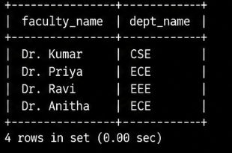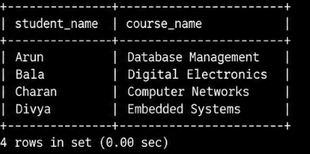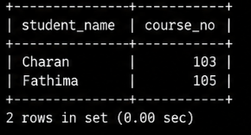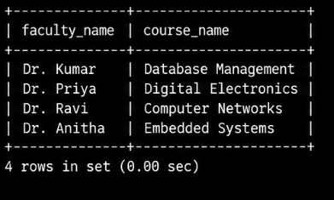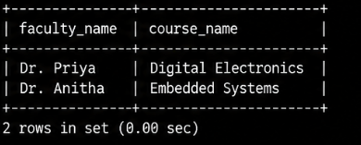

RESULT
Thus, the Equi Join, Inner Join, Left Outer Join, and Right Outer Join operations were successfully performed in MySQL, and the required records were retrieved and verified successfully.

